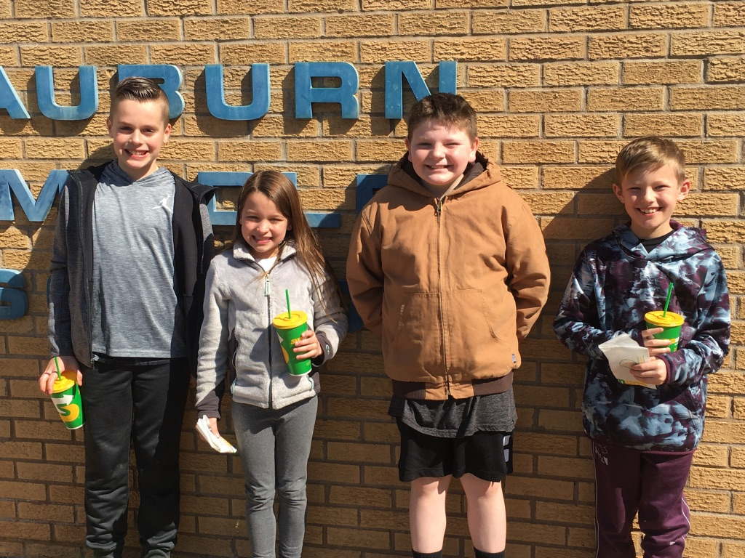Caught Following the Rules Winners

Congratulations to Drew Megginson, Quincy Grider, Robbie Williams, and Eli Hill for being drawn as the winners for lunch at Subway with Mr. Grimm for the month of February. These students were caught following the rules at school by staff members and had their names turned into the office for entry into the drawing. These slips are part of the schools’ effort to recognize students for their positive behavior through our PBIS (Positive Behavior Intervention System). All students who are recognized each month will be put into a drawing held at the end of the year for some awesome prizes.

